Feature image: Step up your wardrobe with a custom suit

Title: Why Every Man Needs a Custom Suit in His Wardrobe
Focus keyword: Custom Men Suit
Secondary Keyword:
Custom Sport Coat
Custom Shirts

Internal link:
Lucho Tie Collection: https://lucho.com/ties/
Lucho Women's shoes: https://lucho.com/women-shoes/

Meta Description:
Discover why a custom suit from Lucho is essential for every man's wardrobe. Experience perfect fit, personal style, and lasting quality to upgrade your style.

Why Every Man Needs a Custom Suit in His Wardrobe

Men's fashion could not get any better than a suit, and more so, a custom-tailored suit, which is you. Not only is it comfortable and molds to the shape of your body like nobody’s business, but it is also the perfect way to communicate your focus on detail and individuality. If it’s a black-tie event or a nearby wedding, or even if just preparing for important meetings in the office, a custom suit from Lucho – the finest Custom Men Suits provider in Houston, TX is a worthwhile investment. Here we would like to share with you why every man should invest in a custom suit, customized sports coats, custom shirts, and ties.

The Power of Fit
The first reason every man needs a custom suit is that this clothing is tailored for the client’s individual measurements. You would agree that off-the-shelf branded clothing is somewhat tailored, a reality because the designers have to accommodate various physical sizes. For this reason, most men are stuck with suits that are very unsuitable for them. Custom suits from Lucho, however, are made from your measurements taken individually. This predisposes all our apparel to ensure that each curve of your body receives the right enhancement.

Getting a well-tailored suit enhances your morale. You appear neat, relaxed, and have the air of a professional. It doesn’t just cloak your body, or more particularly your frame, but enhances the shape and form that is native to a man. We think this kind of customization is not at all possible when compared to the many off-the-shelf products out there.

Unique Personal Style
There is another reason why it is advisable to order a custom suit, which is the aspect of style. With Lucho, you can select from many types of fabrics, colors, and styles of custom shirts you would want. No matter whether you choose a classic charcoal colour, a bright stripe, or a windowpane, a custom suit is a perfect mirror of the owner.

However, customization goes beyond the suit when you see it from a broader perspective. You can even customize your custom sport coat, shirts, and the Lucho tie collection. Notably, this level of customization guarantees that all your apparels complement each other. It’s about achieving the countenance that expresses the essence of your personality.

Quality and Durability
Investing in a tailor-made suit is investing in quality because the result you get will be worth the effort. Lucho suits are generally customized to ensure that it’s made with high-quality fabric that will last long. When it comes to making suits, appropriateness, durability, and tailored make the Lucho suits special as it is made to order. Wearing a custom suit does not come associated with cheap stitching or inferior quality of the fabric used. What you get here is a product that wears like a fine piece of clothing and does not fade or deteriorate for years.

Besides, a custom suit is very useful in a man’s wardrobe. Whether you are attending a wedding, a job interview, or a casual business meeting, a fine custom suit can be worn for any event. You can add a custom suit to your collection that remains popular for upcoming years and can be used in different circumstances.

Confidence Boost:
When you put on a custom suit, it makes you feel appealing and good. It makes you feel like a strong man or a capable woman ready to conquer the world. It has become clear to most people that there is a correlation between your physical appeal and the way you act. Bespoke attire ought to be a life changer in the daily life and business life of an individual.

Investment in Yourself:

A tailored suit ensures that you make an investment that would benefit you in the long run. In other words, it is an affirmation of the fact that you hold quality and style in high esteem. It ascertains that you have clean and well-groomed clothing most of the time. A stitched suit from Lucho doesn’t only mean you own tailor-made garment, but it is evidence of a wish to do business at a higher level.

Ready to Accessorize with Lucho’s Tie Collection and Women's Shoes

No suit can be complete without accessories. Lucho’s Tie Collection is a perfect fit for every man and every occasion. Whether choosing to wear a paisley print tie or a relatively geometrical one, the tie can make the final note to wear a clothing set.

For any suit, adding accessories does not solely end with tying. Lucho also has a variety of women's products in shoes that could perfectly fit any occasion of your choice. From sophisticated formal wear to casual wear shoes, Lucho women’s shoes are a fitting accompaniment to the fine-tailored suit.

Ending Note:
Finally, it becomes vivid and clear that a custom suit is not just an ordinary garment. Your custom outfit expresses what you prefer for style and quality, alongside your personality. Each man wants to display confidence through his clothing. The custom men suits and sports coats, along with shirts and ties at Lucho, enable you to find wardrobe pieces that reflect your personal character and style.

Wearing a suit from Lucho becomes an investment in yourself. It involves quality, which for many is the paramount consideration, and also fit, as well as style. No matter the occasion, whether it's a business meeting in the corporate world or a special occasion, the use of a Lucho suit will GUARANTEE you the best look you desire.

So why wait? Visit Lucho – the leading men’s custom suit store in Houston – to create a wardrobe that is as exceptional as you are different. Take the expert guidance from one of the leading tailor shops in Houston and feel the difference in your persona.
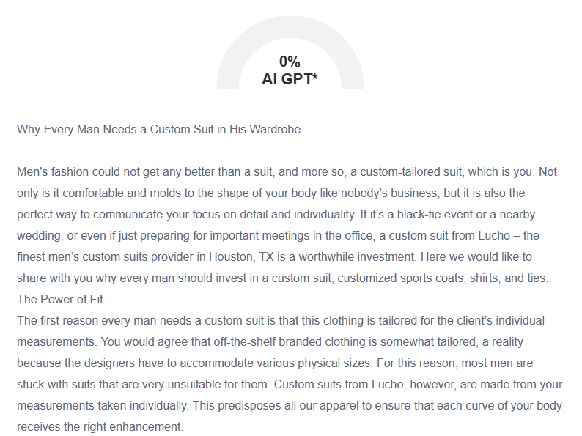
GMB

Experience the transformative power of a custom suit from Lucho, Houston's premier men's custom suit provider. Our custom-made suits guarantee a perfect fit because we measure every person precisely to complement your real appearance and unlock newfound self-confidence. Our vast selection featuring fabrics and styles, and colors allows you to select a suit that expresses your personal style. Investing in a Lucho custom suit means obtaining high-quality, durable apparel that will fulfill your dressing needs for multiple years. Our suits are built with exceptional materials and skilled workmanship to resist common flaws that commonly appear in factory-made suits. People attending occasions such as weddings or seeking employment, or leading business meetings, will make a strong impression wearing custom suits from Lucho. Your tailored ensemble reaches its final touch with the exclusive ties from our collection that harmonize perfectly with your tailored ensemble. The shoe collection designed for women at Lucho caters to all events and occasions. A custom suit represents more than clothing because it demonstrates your steadfast dedication to premium essence, together with elegant fashion and individual top-tier performance. You can consult our expert tailors at Lucho, who will help you develop a wardrobe that expresses your incredible self as you design it. Upgrade your appearance, boost your confidence, and experience the difference that true customization makes.

